## Tools Needed:

* Screw Driver

## Hardware Needed:

* Raspberry Pi 4
* Voltaic V75 Battery
* Raspberry Pi NoIR V2 Camera
* Sixfab Outdoor Waterproof Case
* Sixfab Power Management Hat
* Sixfab Cellular 4G-LTE USA Hat
* Laptop
* Micro-USB cable

## Steps:

**Raspberry Pi Software Setup**

**IMPORTANT:** When the system is fully put together and connected to SixFab you will need to download certificates from the Sixfab dashboard in order to connect to the backend after registering a SIM card.

1. Navigate to Sixfab’s Dashboard and sign in
2. Click on devices, and the device that you need to register
3. Scroll down and find *copy installation code*
4. 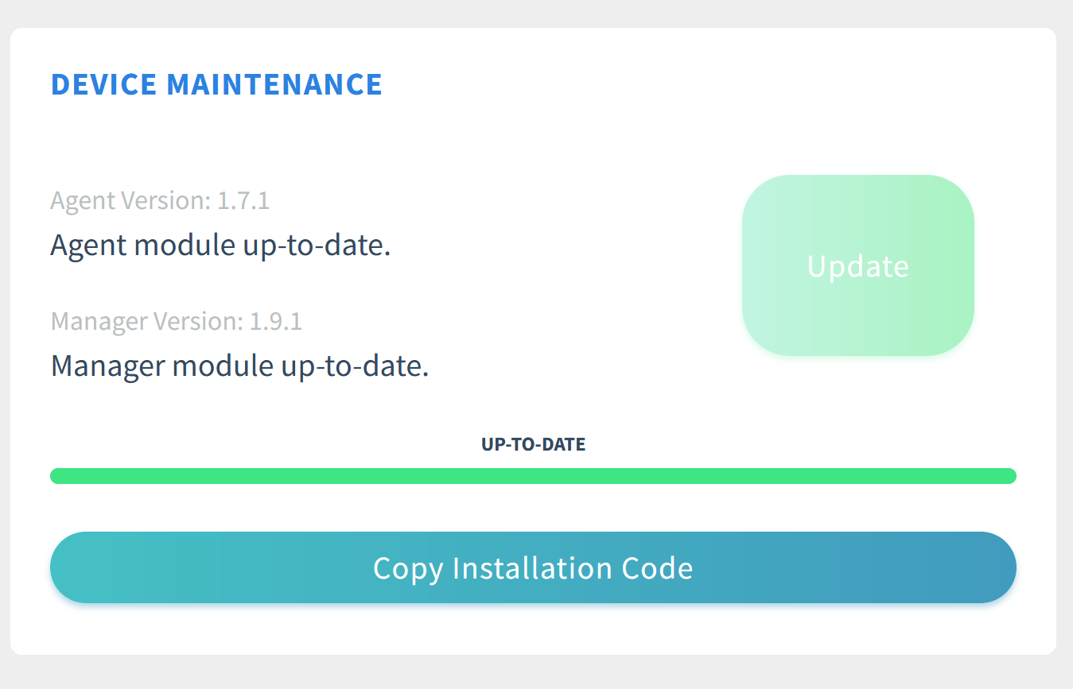
5. Click that command and paste it into the Raspberry Pi’s terminal
6. The Pi will now be connected to the backend
7. Anytime the SD card gets reset this will need to be done.
   1. **Method 1:** You may simply flash an microSD card with the latest image in our GitHub here: link TBD, you’ll then have to customize the *config.txt* to match the specifications of the parking area. This image will work as long as you are using a Raspberry Pi 4, Telit Cellular Module with the Sixfab 3G/4G LTE Cellular Hat. Note if any hardware is different, this may not work.
   2. **Method 2:** Install a fresh version of Raspian and run the install script.
8. Flash SD Card with Raspbian Image
   1. Download at: <https://downloads.raspberrypi.org/imager/imager_latest.exe>
   2. Install the imager and follow the instructions
   3. Choose the Non-GUI version of Raspberry Pi OS when prompted to select a OS
9. Run install Script (Located in Github Repo)

**Hardware Setup**

1. Open and remove bracket from the Sixfab case.

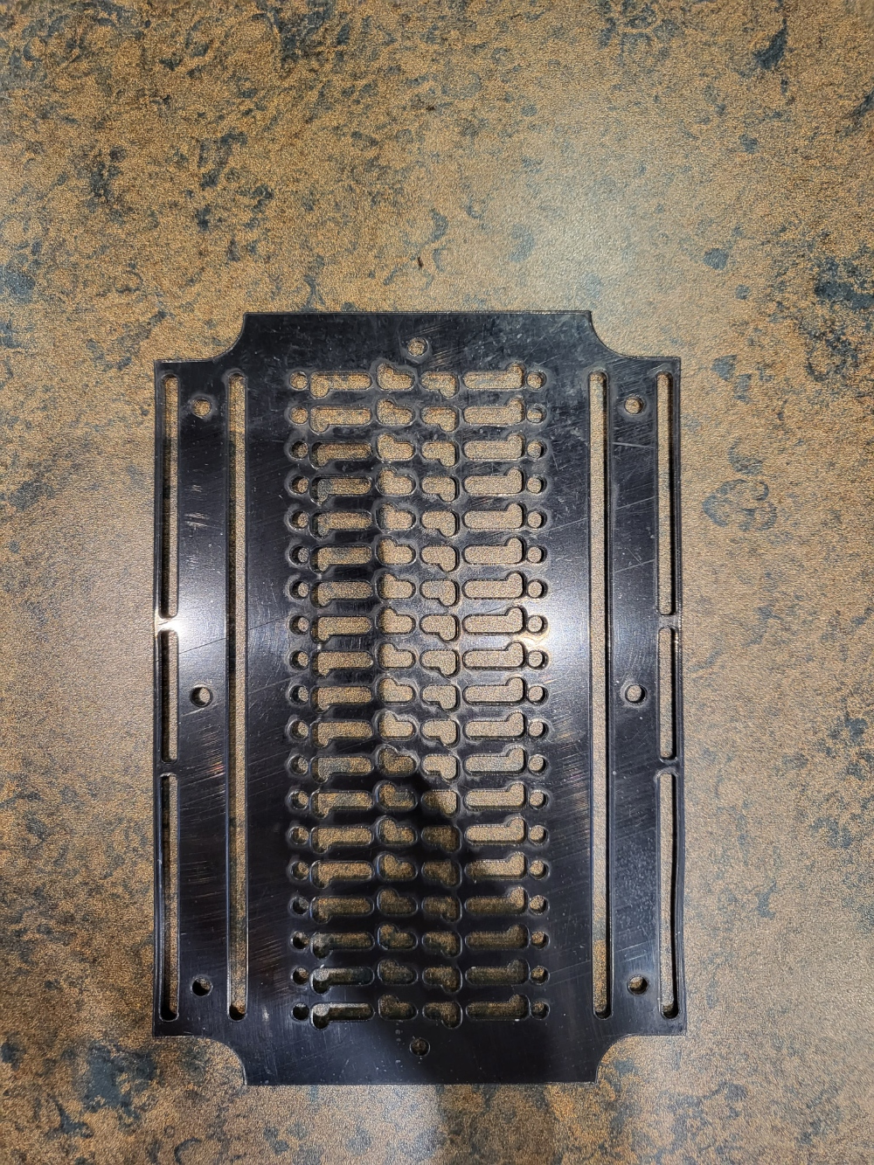

1. Open the Power Management hat
   1. Get the two taller standoffs, two of the smaller screws, the pin riser, and small aluminum heatsink.

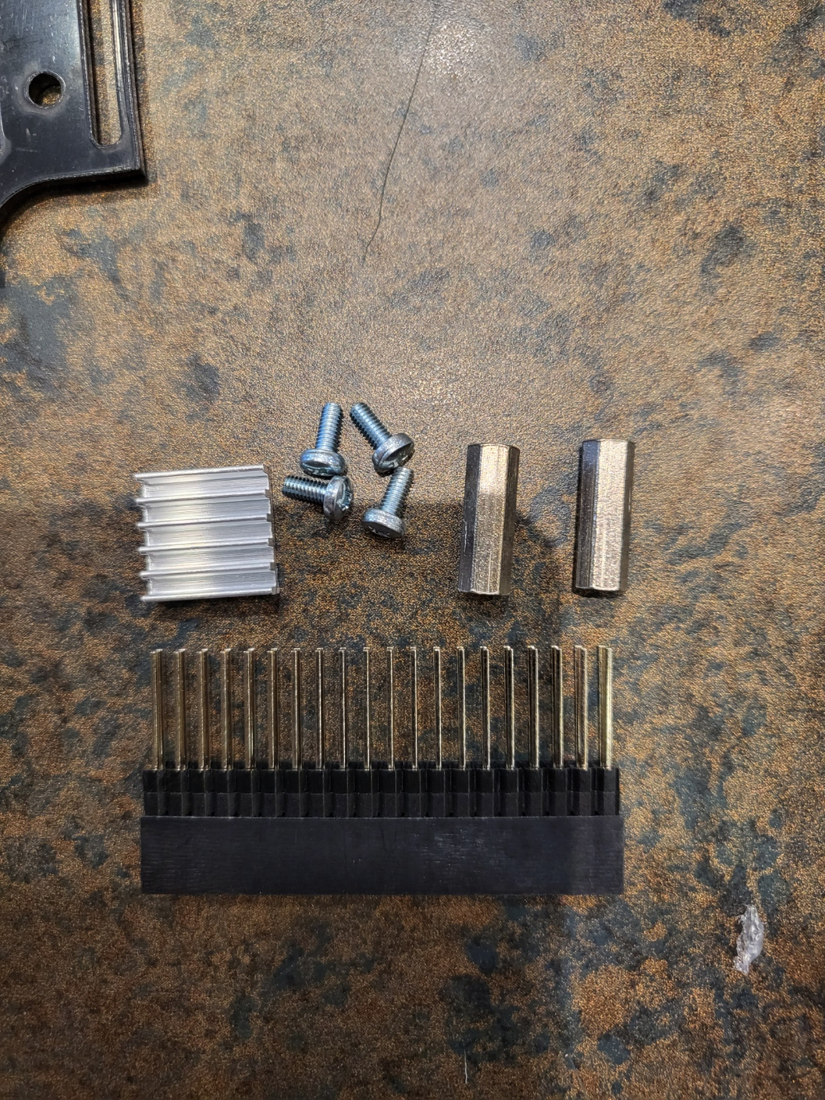

* 1. Attach the Pin Riser to the Raspberry Pi

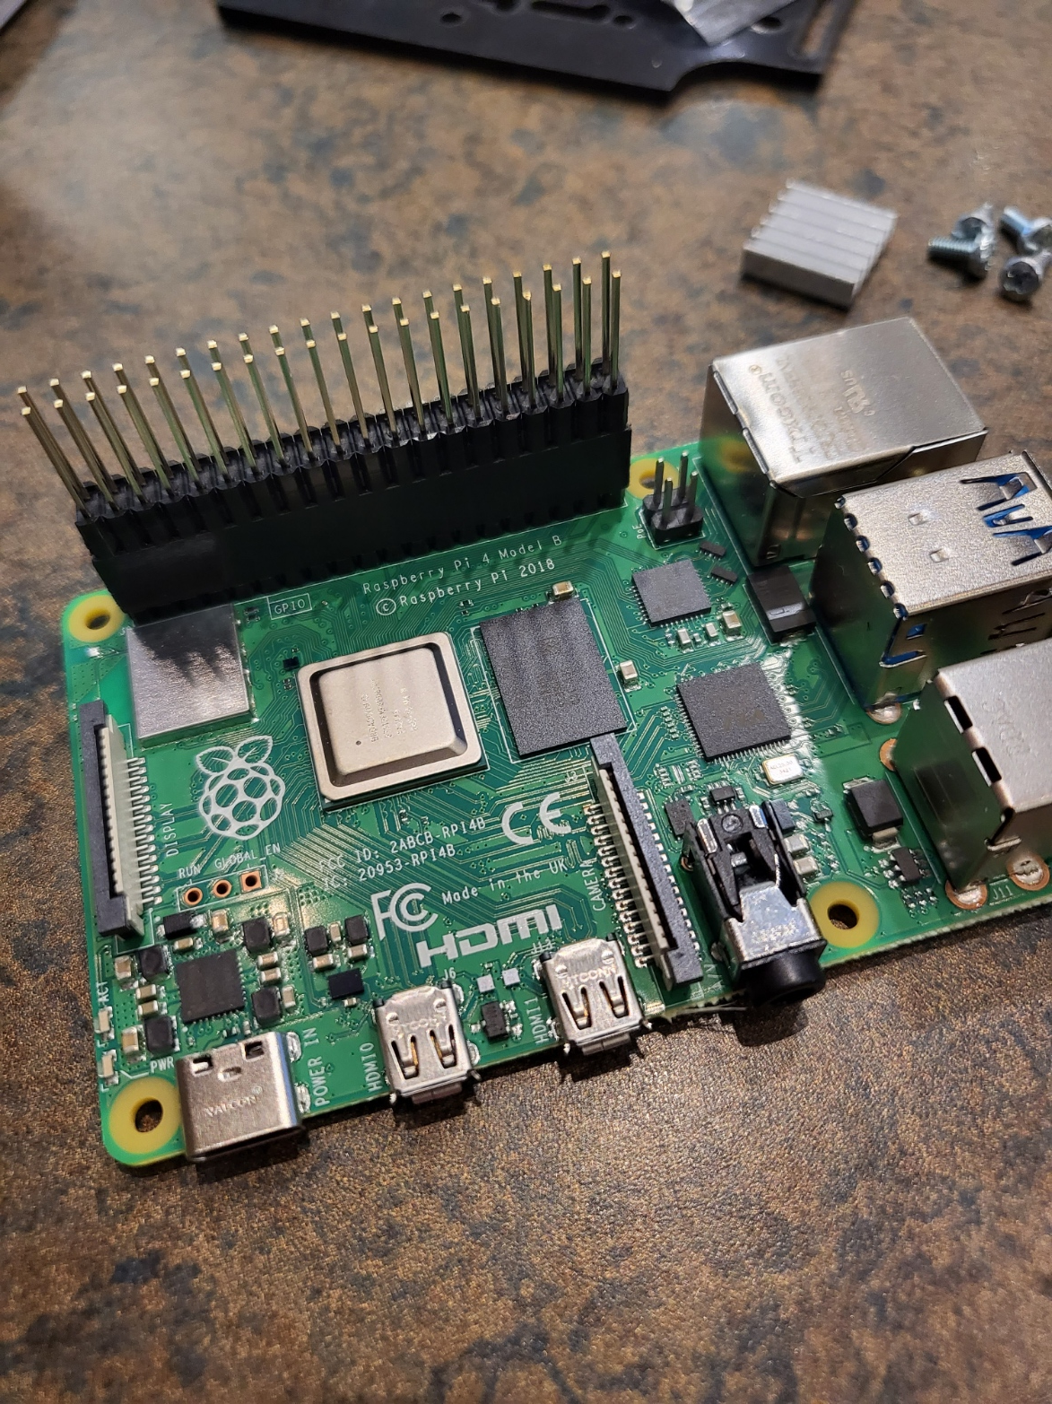

* 1. Take of the 3M Tape cover from the heatsink and place it on the CPU

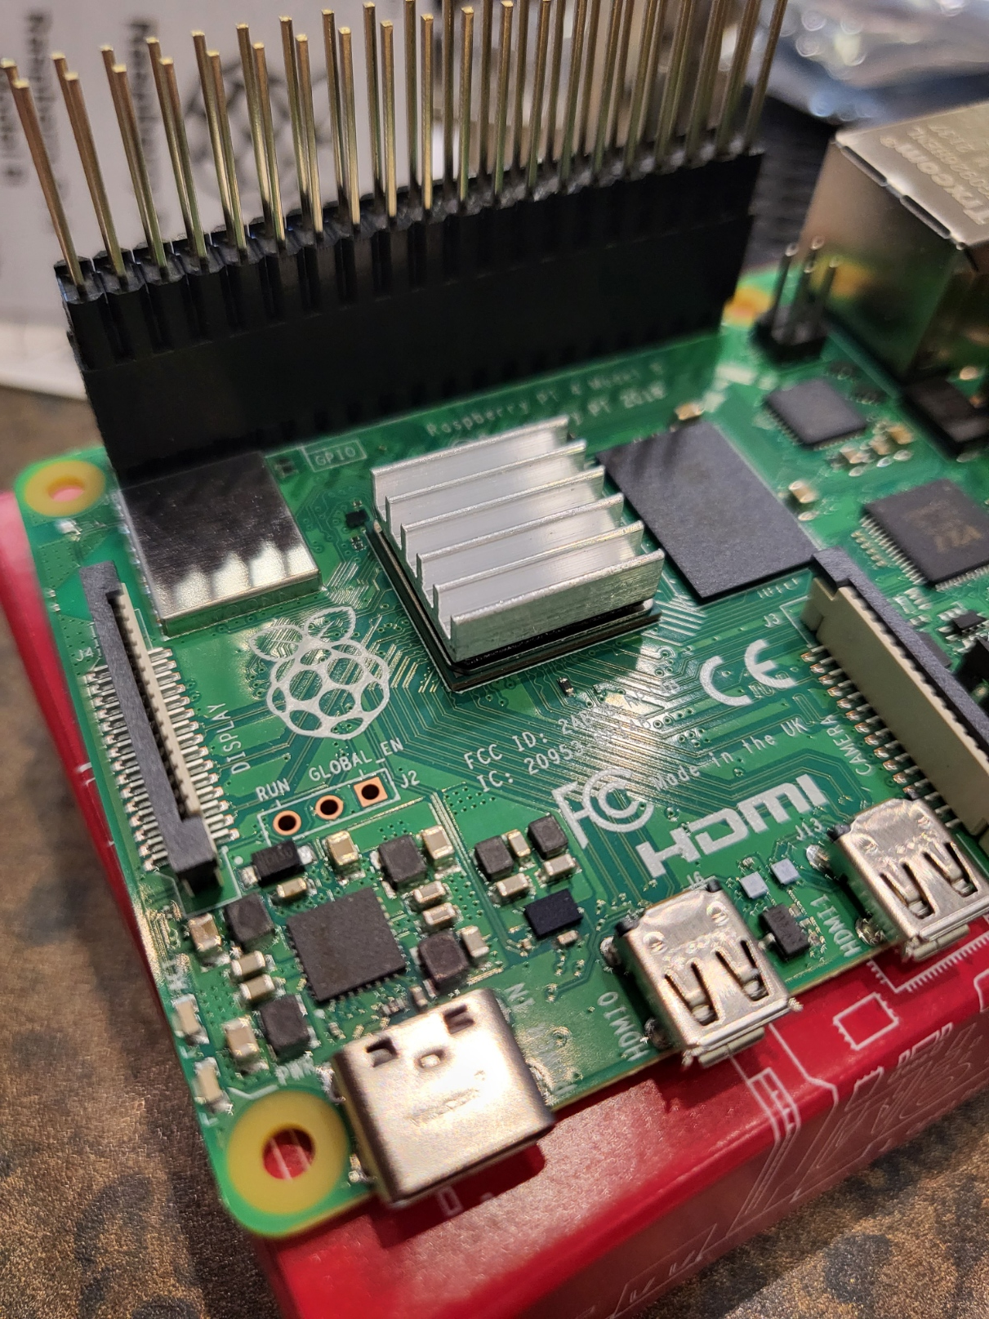

* 1. Install the Standoffs on the Power Management Hat using a screwdriver(Side opposite of the pins)

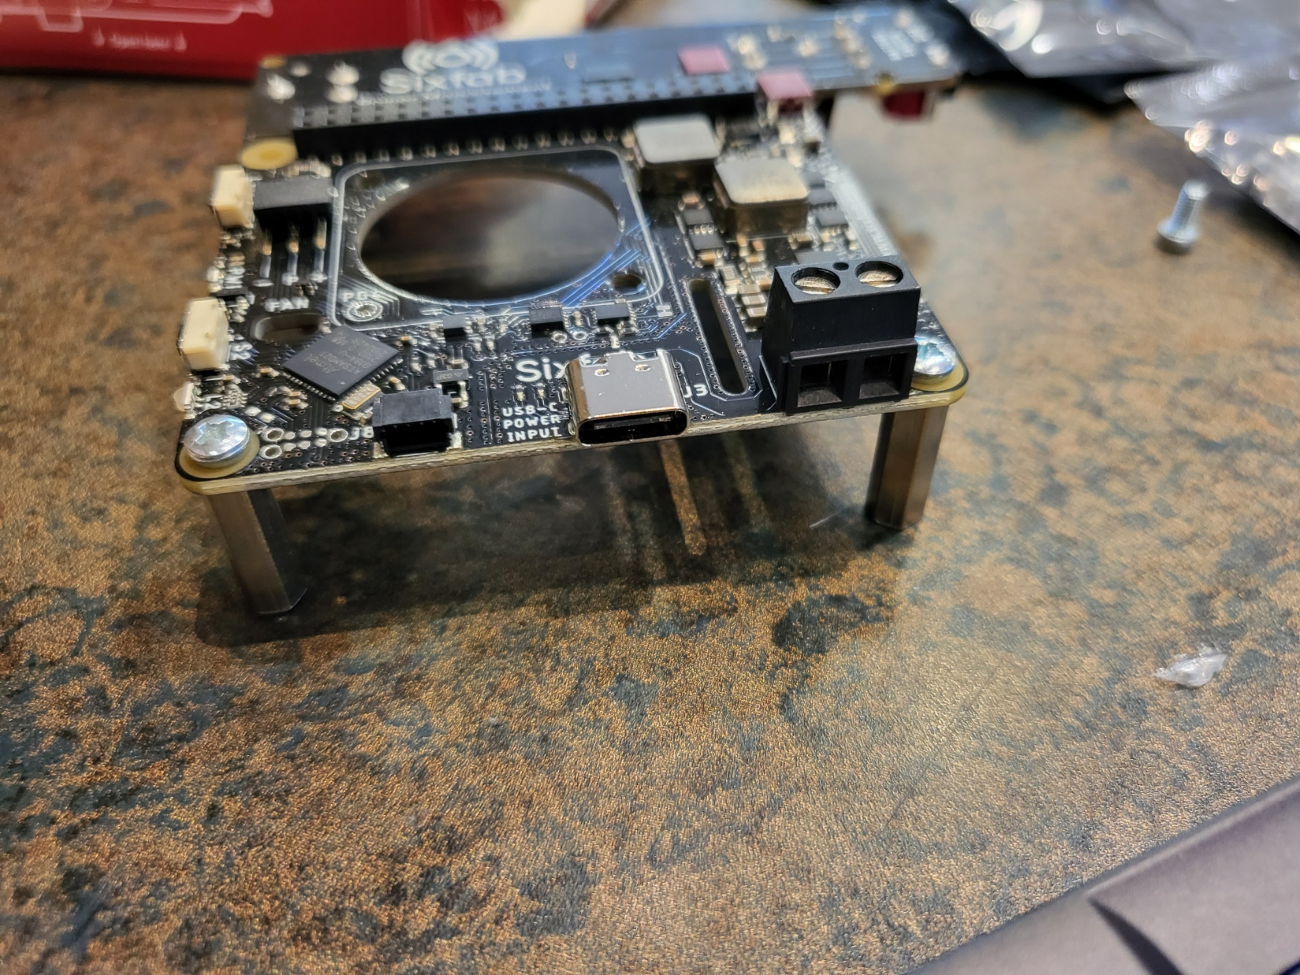

* 1. Install the camera Module (Undo the Camera from Ribbon Cable for easiest installation)
     1. Lift up on black tab to free the ribbon cable, and firmly insert the cable into the port.

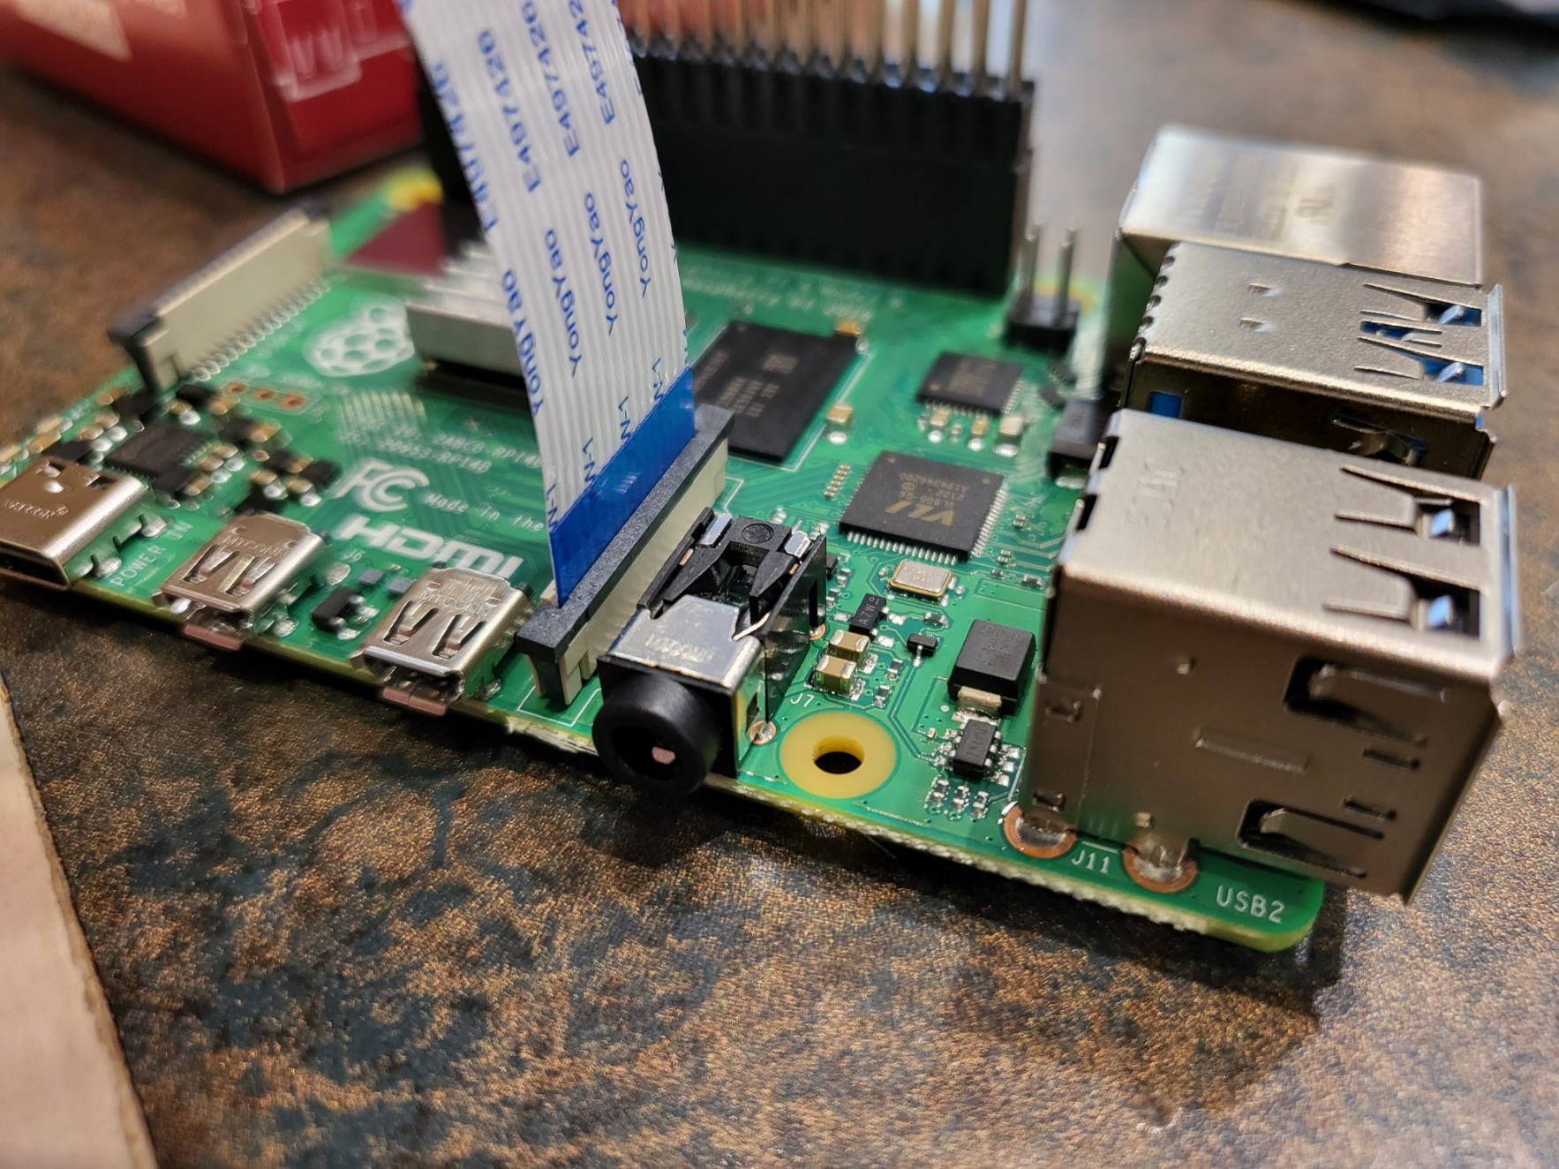

* 1. Install the power hat to the Raspberry Pi main pins. ( Do not screw the standoffs into the board yet)
     1. Feed the camera cable through the slot in the power hat. 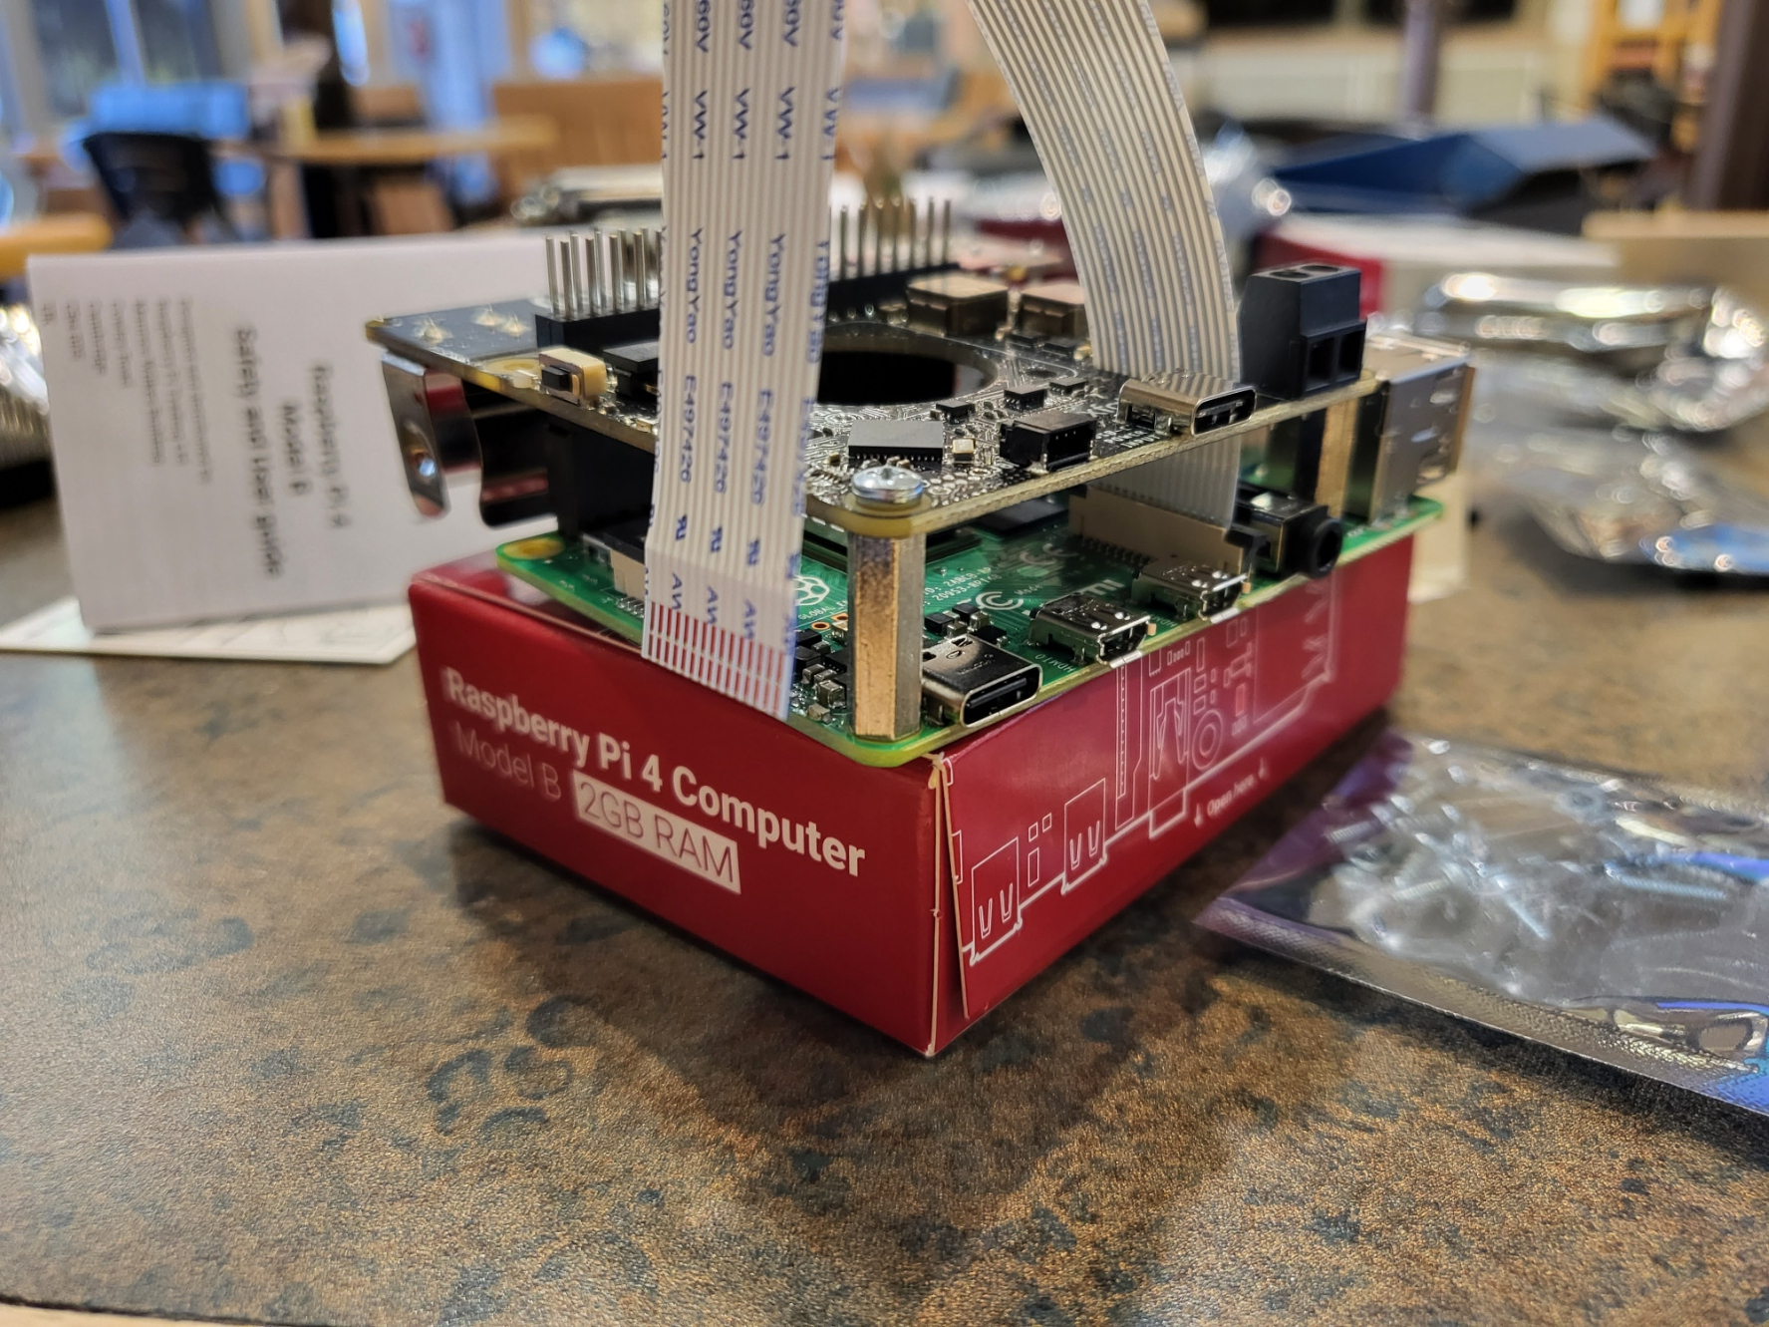
  2. Get one of the smaller standoffs from the cellular networking hat box, and the smaller pin riser from the Sixfab Networking box.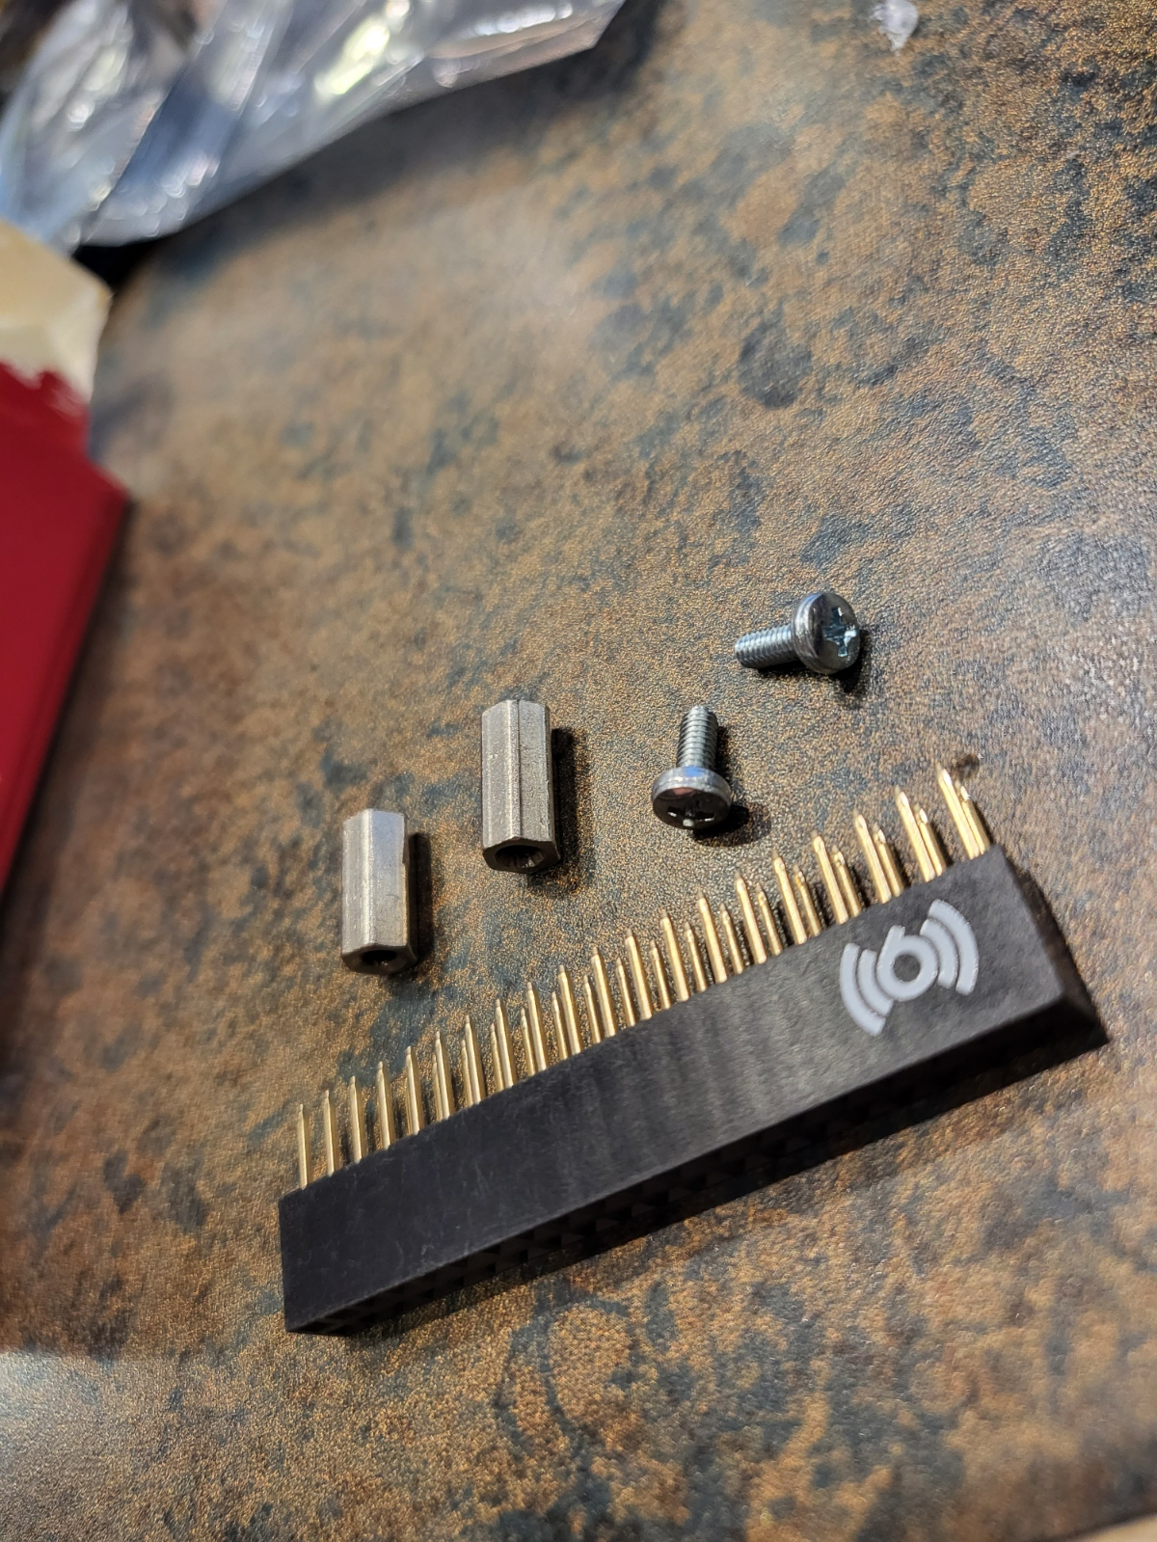
     1. 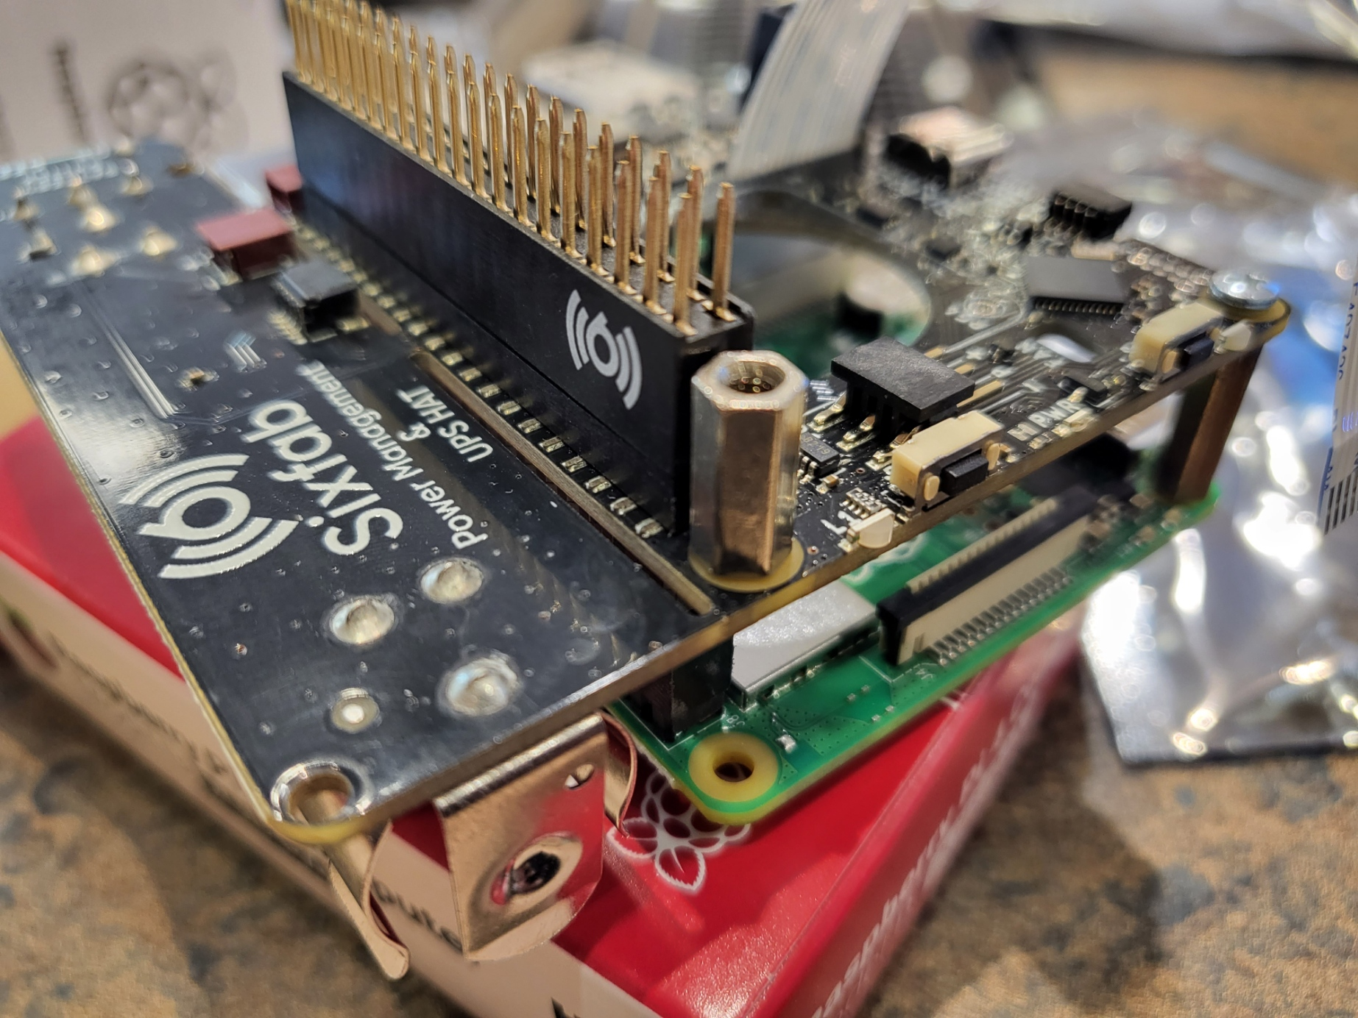
  3. Next, set up the cellular hat for install.

**Cellular Setup**

1. Remove SIM card holder, remove the Micro sim card size from envelope and insert into SixFab Cellular IoT hat.
2. Follow the instruction here, select on the Cellular module you have: <https://docs.sixfab.com/docs/raspberry-pi-3g-4g-lte-base-hat-getting-started>
3. Cellular IoT hat should look like this after attaching antennas and sim card:
4. 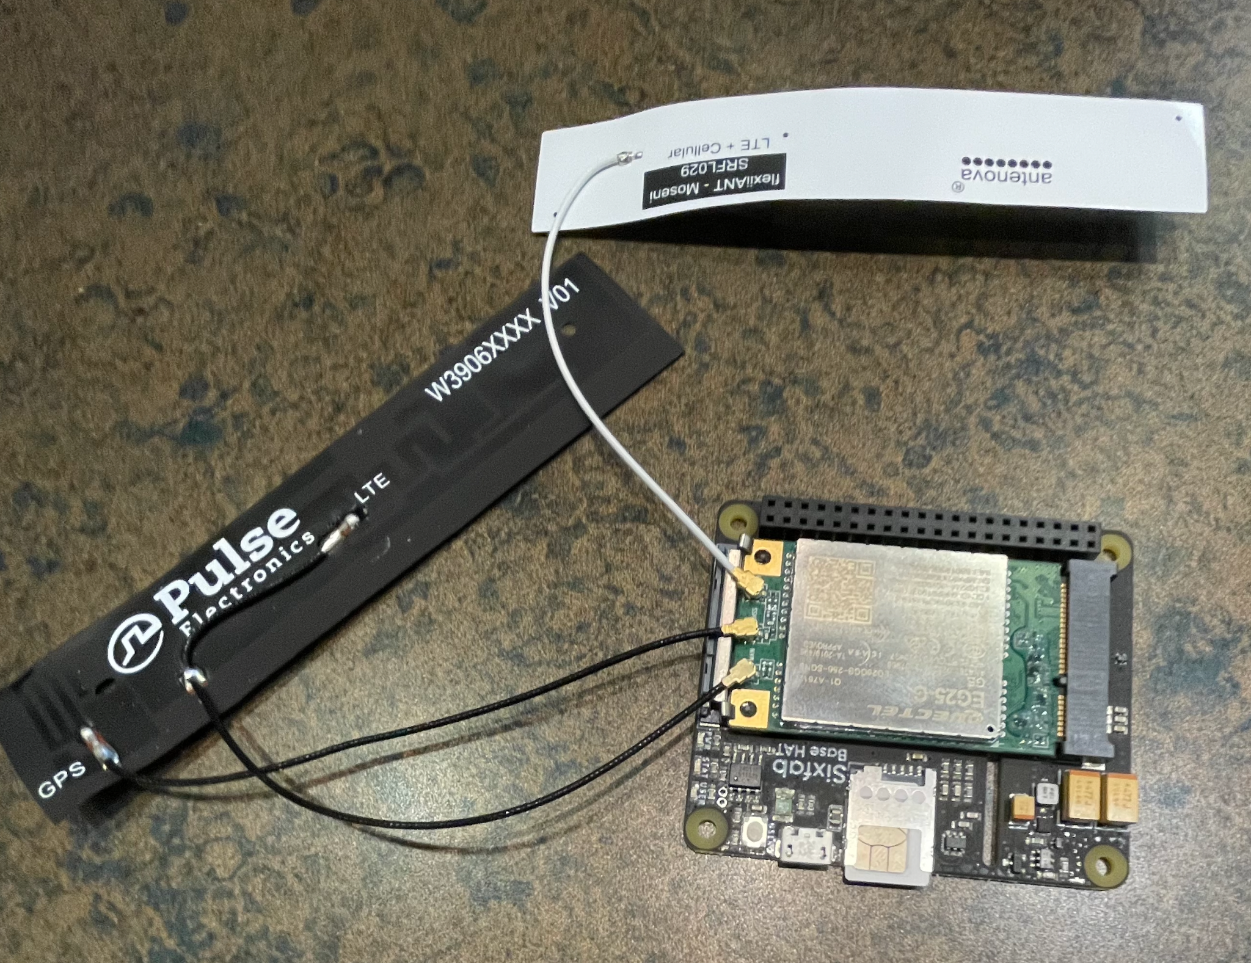
5. IMPORTANT: You will also need to connect the hat to the Raspberry Pi using micro-usb cable to one of the USB ports on the Pi itself in order for the networking to work properly.

**Registering Sim Card**

1. Go to Sixfab Core, connect.sixfab.com and enter credentials provided to you to login.
2. After logging in, in the sidebar, click *Register Sim Card*, and enter the SIM ICCID, which is written under the bar code in the Sim Card Holder and outlined in red in the image below.
3. 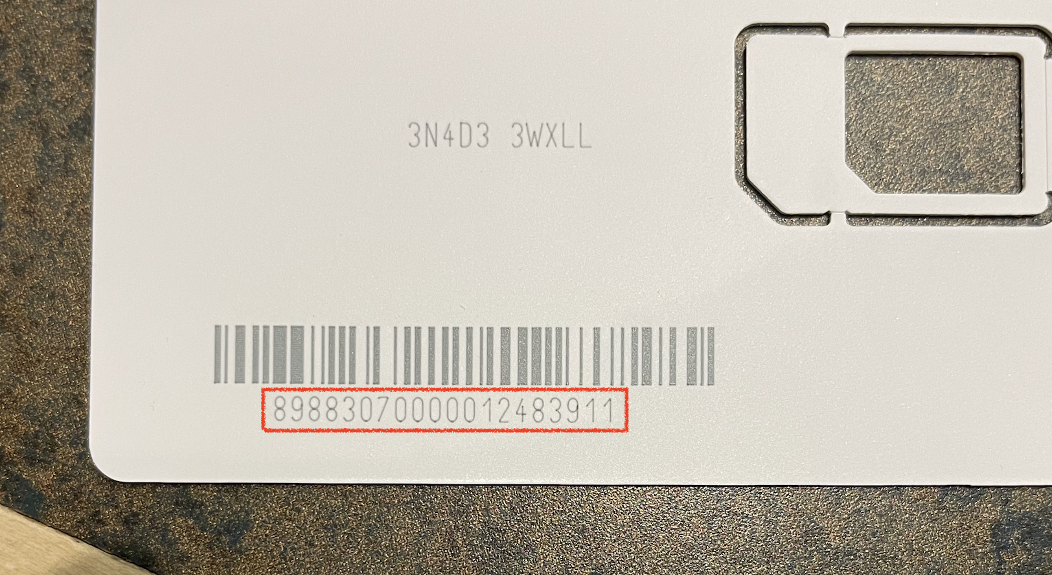
4. Click on your newly created SIM and set it to ‘Active’
5. Then Navigate to My SIMs, click create device under your new sim.
   1. Most likely, you have a US module, select APAC and Raspberry Pi. This requires no additional action.
   2. If your Cellular Module is the Global version, select Global and Raspberry Pi and run generated code on the Raspberry Pi.

### Install the Networking hat on top of the Power Hat

1. Set the hat onto the pins, and screw in the single small screw with a nut as a spacer in between the standoff and the board.

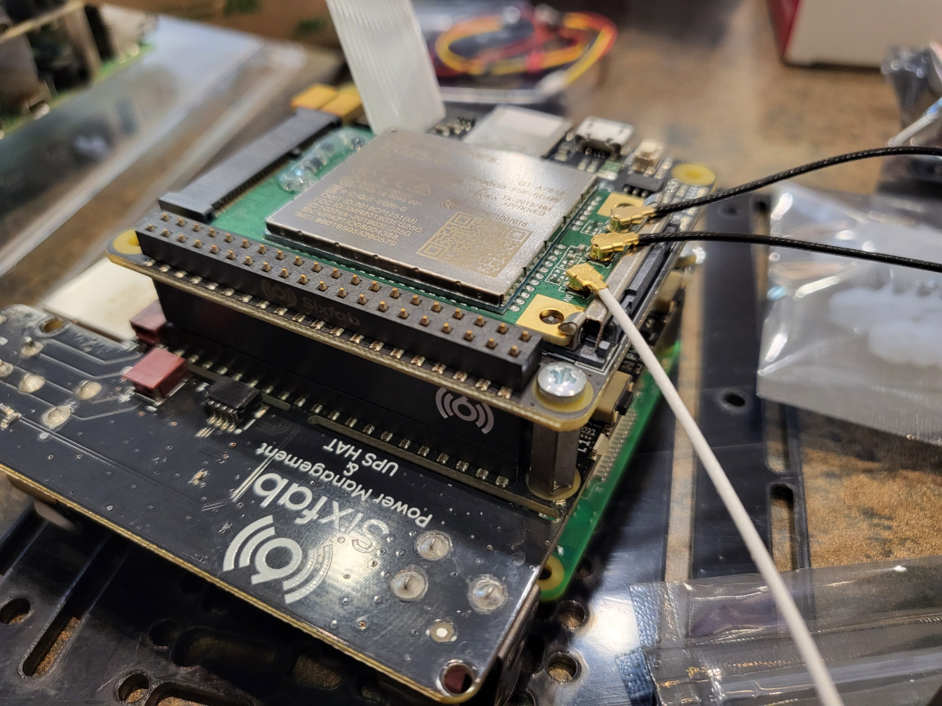

1. Install the camera onto the ribbon cable.

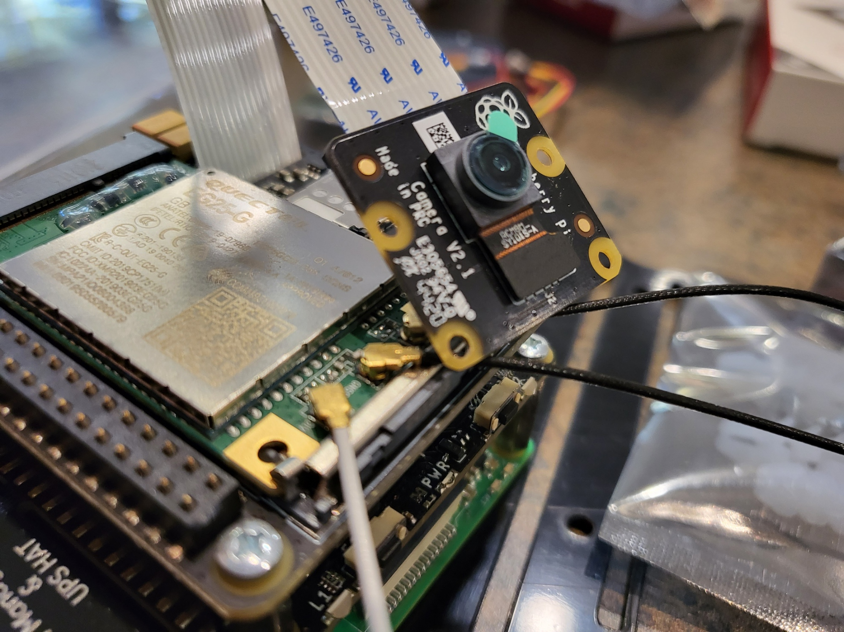

1. Install the Small battery into the power hat.

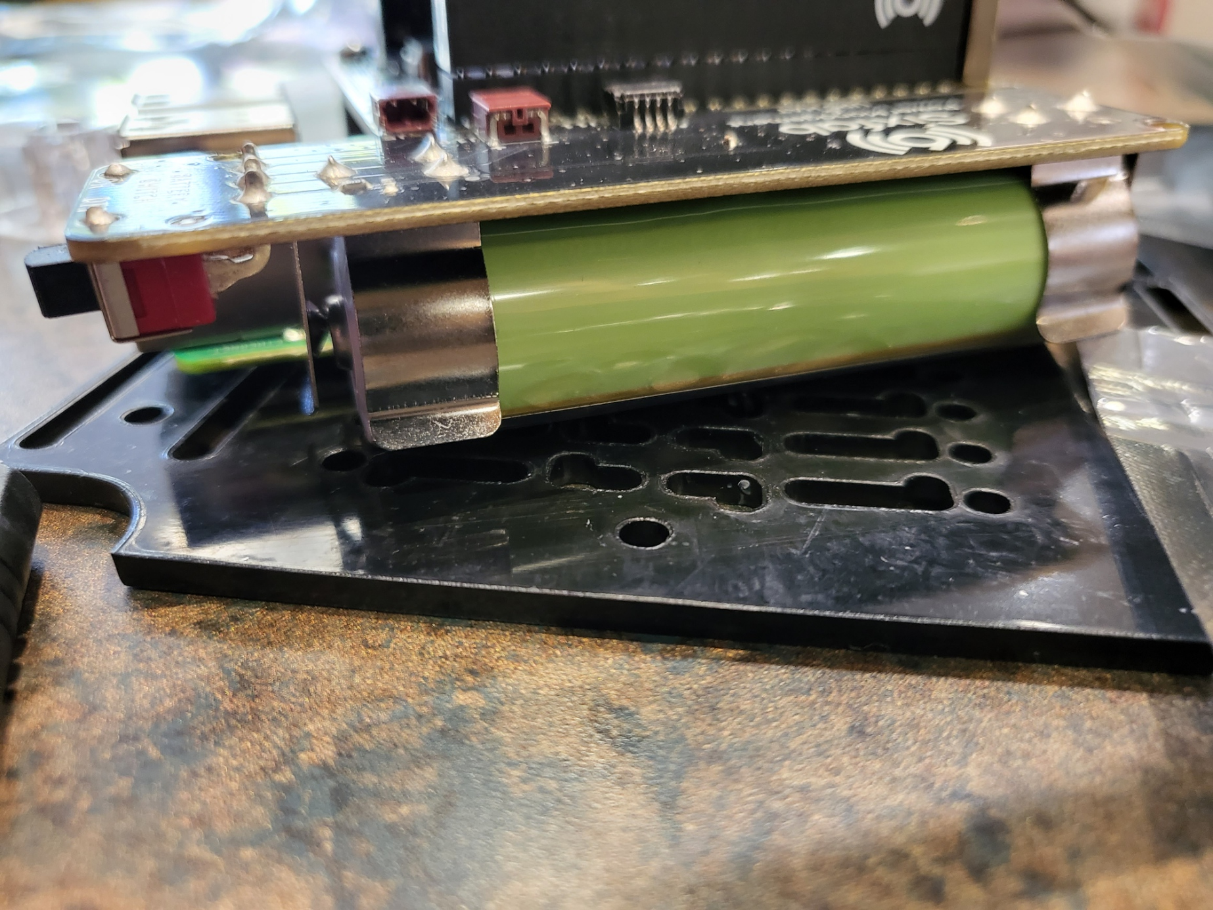

1. Install the sim card with the flashed image.

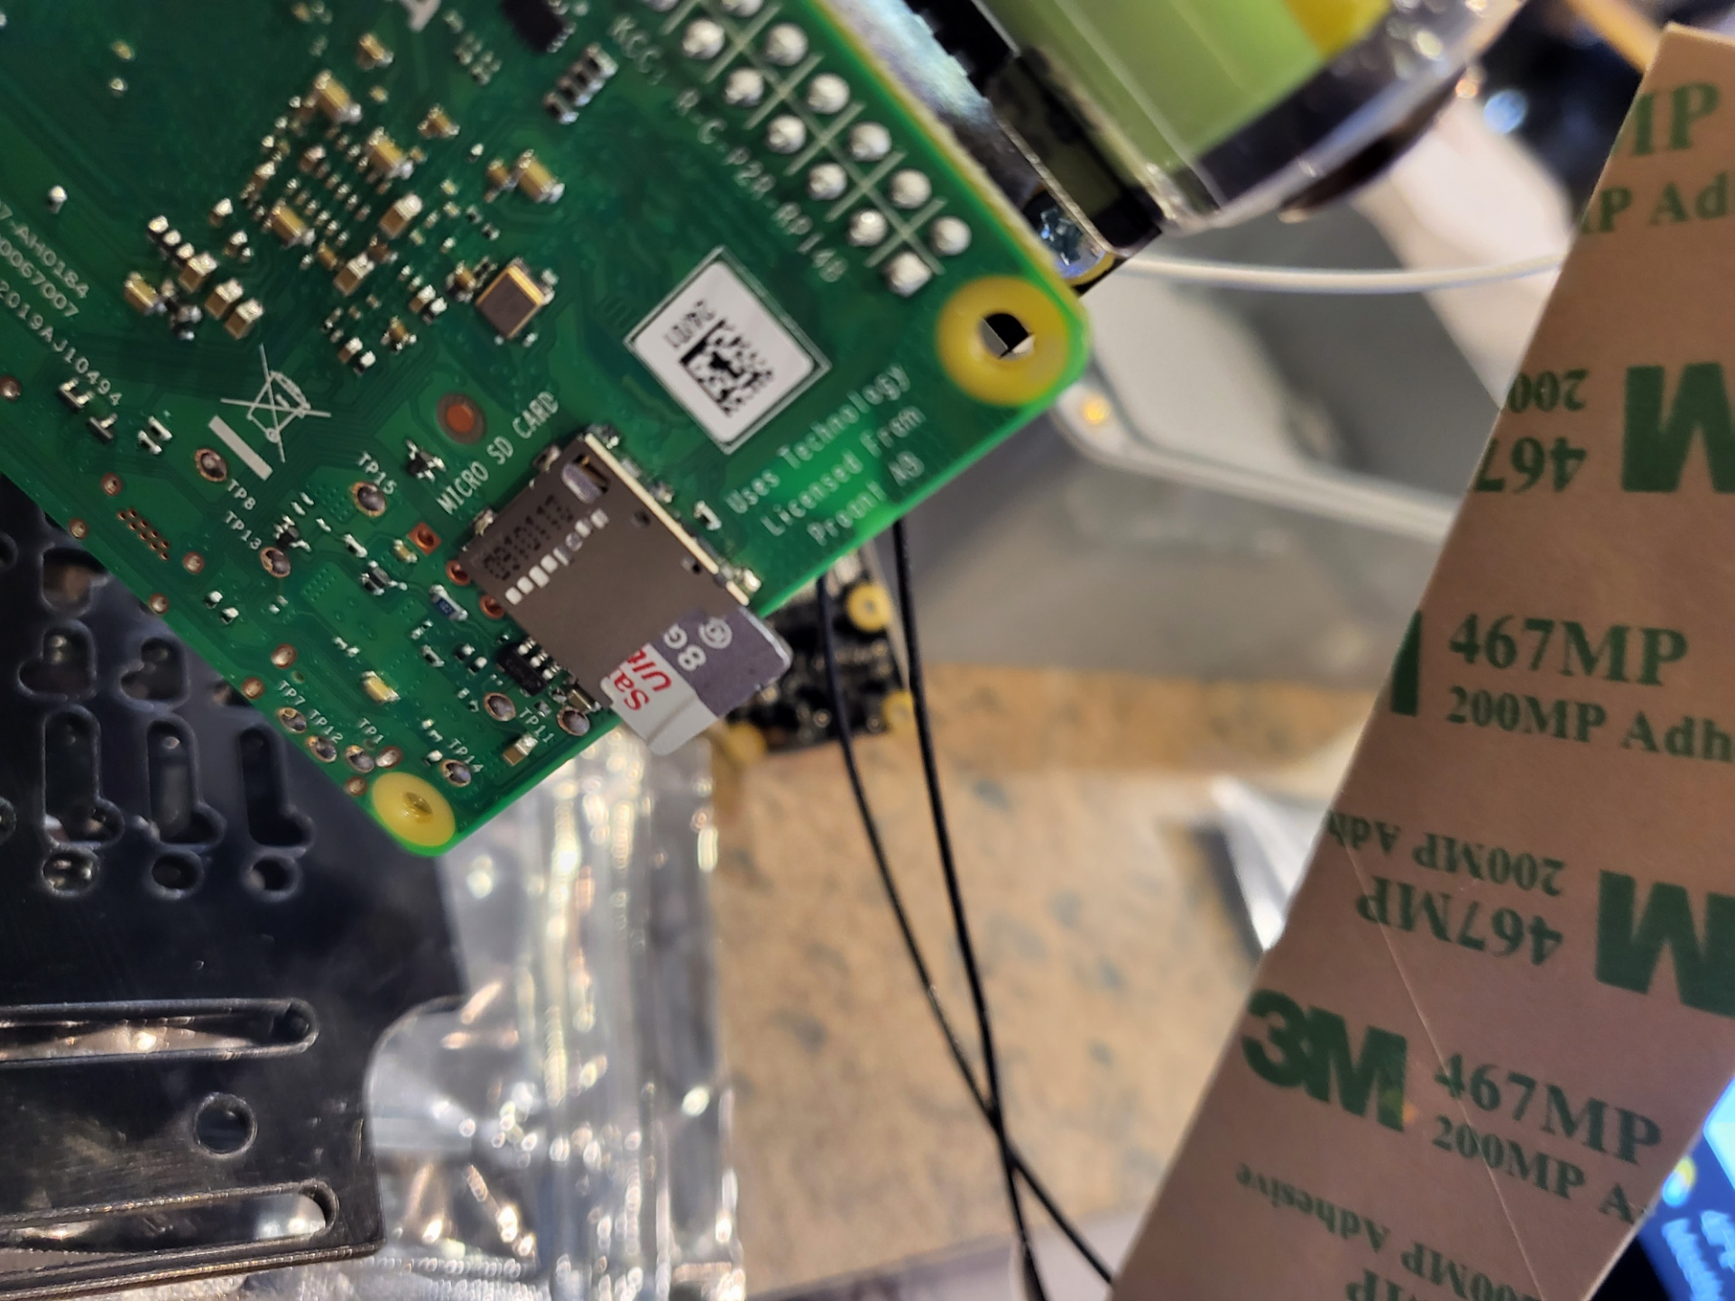

1. Get 3 small screws and 3 nuts to mount to the backplate.

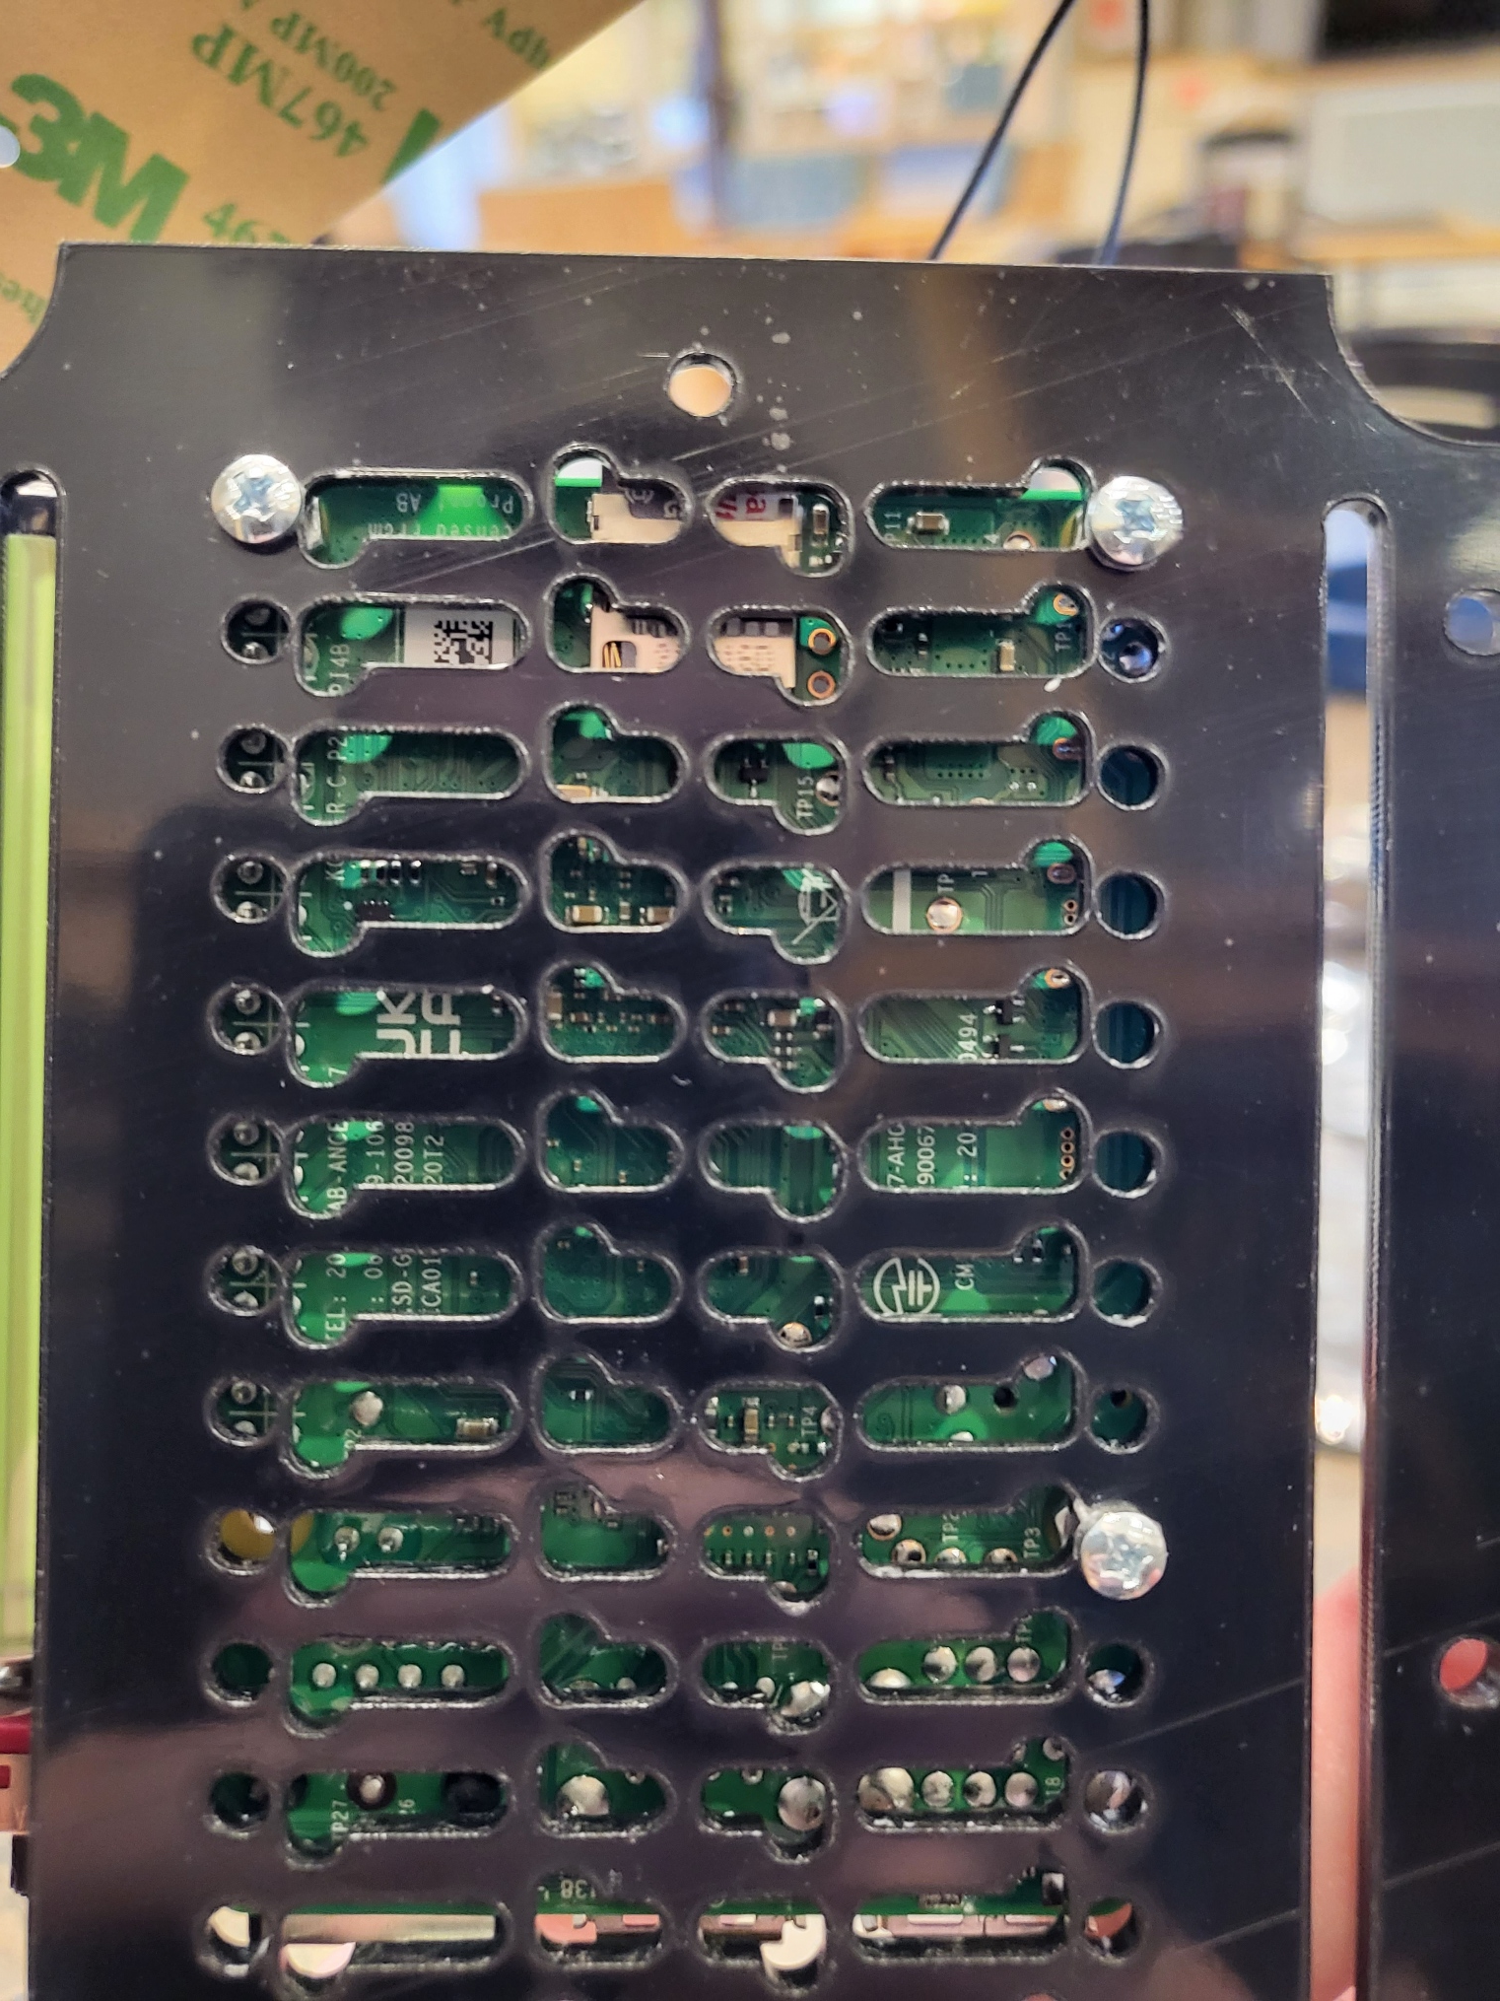

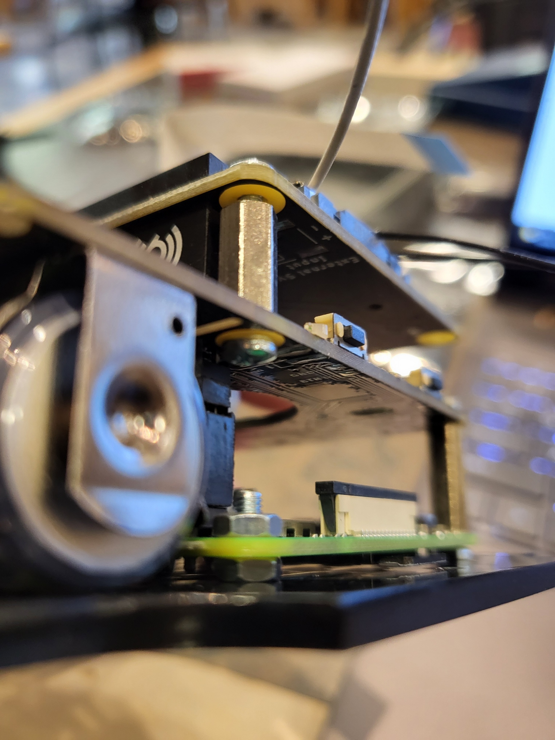

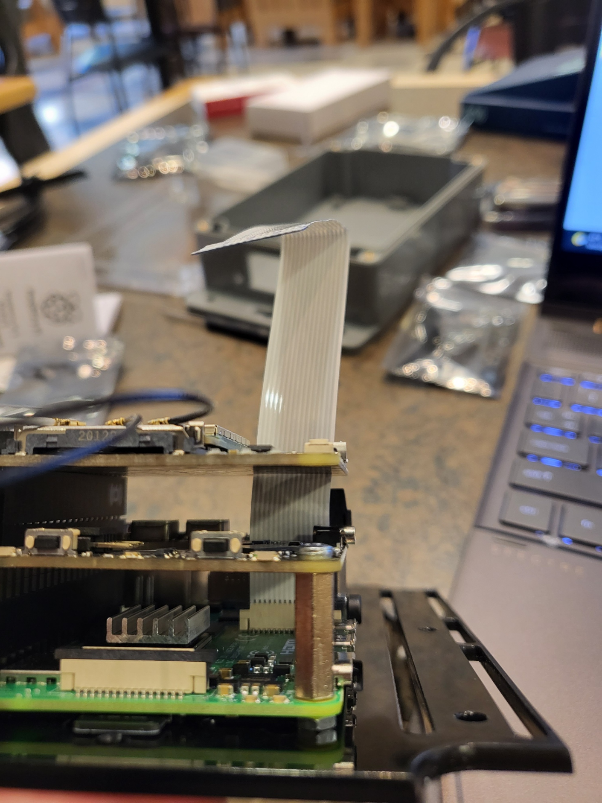

All done!

Run some of the demo code from GitHub to test the system's functionality to ensure everything is set up correctly.